Lab 10:

Leet code :1

Leet code :2

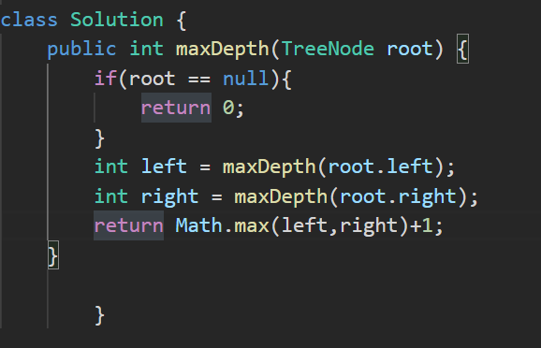

Leet code:3

